DRAFT
Technical Design

Melbourne IT OFC
MEL IT AP Payables Master Supplier Report



Author: Tony Whelan
Creation Date: 29 July 2016
Last Updated: 10 August 2016
Version: 1.0
Table of Contents

1. Requirement 3
2. Solution Overview 3
3. Technical Objects 4
3.1 BI Publisher XML Data Definition File 4
3.2 BI Publisher RTF Report Template 4
4. Configuration 4
4.1 Define Concurrent Program 4
4.2 Define XML Data Definition 6
4.3 Define XML Template 6
4.4 Update Request Group 7
4.5 Define Value Sets 7
4.6 Define Value Set Values 9
4.7 Define Descriptive Flexfield Segments 9
5. Assigning Default Expense Accounts to Suppliers 11
6. Entering Additional Supplier Site information 12
7. Report Execution 12

Requirement

Melbourne IT have a requirement for a Payables Master Supplier Report listing details of all AP Payables Suppliers.

The Data columns include:
Business Unit
Supplier Number
Supplier Name
Supplier Site
Status
Currency Code
Terms
Payment Method
Bank Name
Bank Account Name and Number
Bank Branch Name and Number
Country
Foreign Payment Flag
Vat Registration Number
Tax Flag
Address
Email Address
Average Invoice Amount
Approver Positions and Names
Billing Period
Assigned Payment Week
Assigned Distribution Set Account Codes

The Parameters include:
Business Unit.

Solution Overview

Report MEL IT AP Payables Master Supplier Report has been developed and configured using the Oracle EBS XML BI Publisher. This document describes the configuration and execution of XML Report MEL IT AP Payables Master Supplier Report to provide the above information.

The additional non-standard information highlighted in blue in the previous section above can be entered and maintained using existing Distribution Sets functionality and also by using the Descriptive Flexfield in the Address Details page of the Supplier Creation form.

Technical Objects

BI Publisher XML Data Definition File
This file contains the SQL query, data elements and parameters for the report.
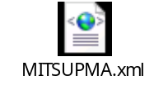

BI Publisher RTF Report Template
This file contains the xml markup and report layout definition for the report.


Configuration

Define Concurrent Program
Responsibility: System Administrator
Menu Path: Concurrent -> Program -> Define
Form: Concurrent Program
Purpose: Define a new concurrent program.

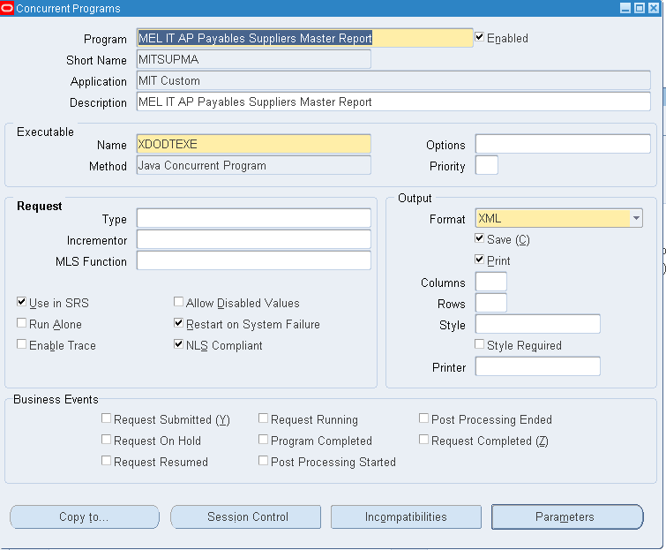

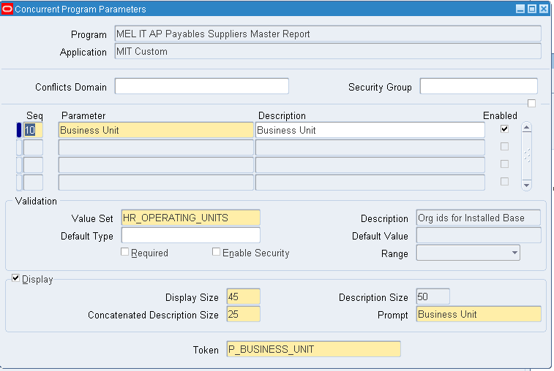

Parameters:
Seq | Parameter | Value Set | Disp. Size | Prompt | Change Reference
10 | Business Unit | HR_OPERATING_UNITS | 45 | Business Unit | P_BUSINESS_UNIT

Define XML Data Definition
Responsibility: XML Publisher
Menu Path: Home -> Data Definitions
Form: Data Definition
Purpose: Define the Data Definition in XML Publisher; attach the XML Data Definition file.

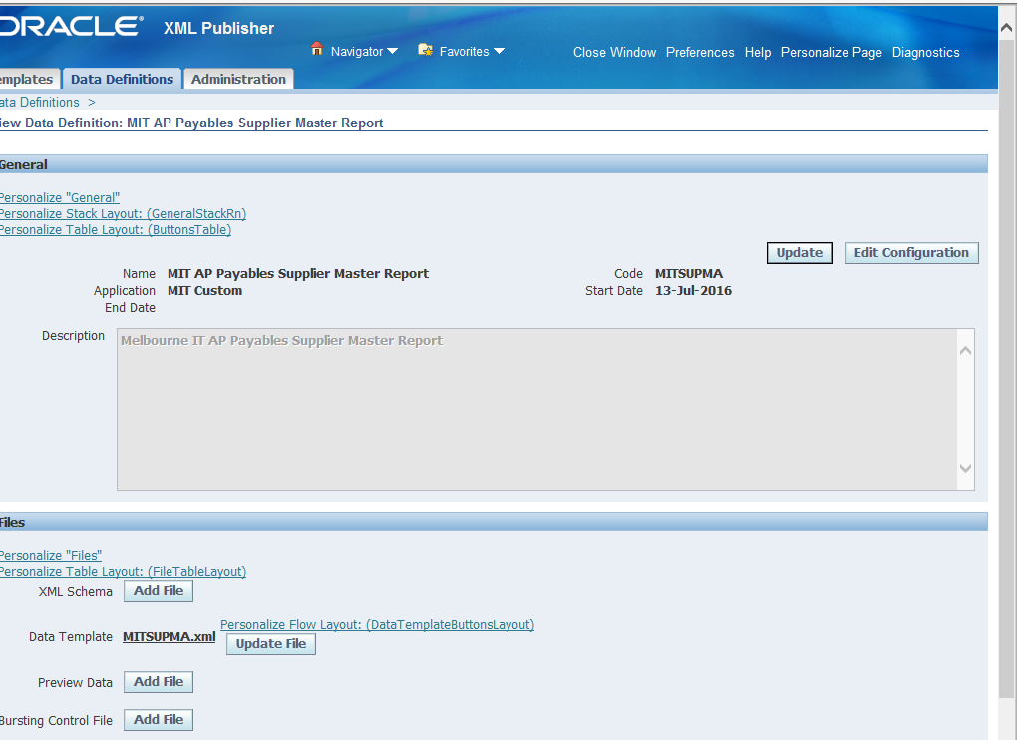

Define XML Template
Responsibility: XML Publisher
Menu Path: Home -> Templates
Form: Templates
Purpose: Define the Layout Template; attach the RTF Report Template file.

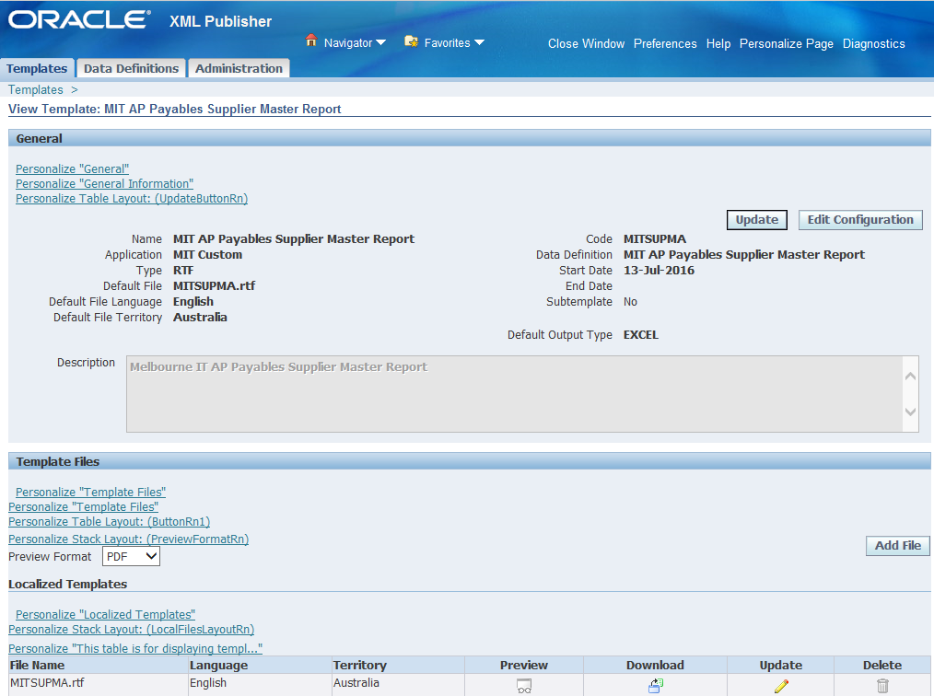

Update Request Group
Responsibility: System Administration
Menu Path: Security-> Responsibility -> Define
Form: Request Group
Purpose: Add the Report to the Payables Request Group
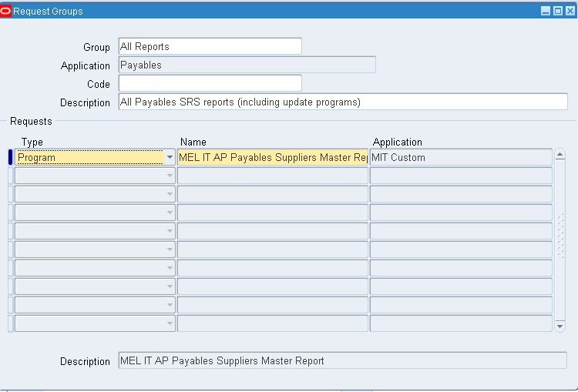

Define Value Sets
Responsibility: System Administration
Menu Path: Flexfield -> Validation -> Sets
Form: Value Sets
Purpose: Define Value Sets used in the Supplier Site DFF

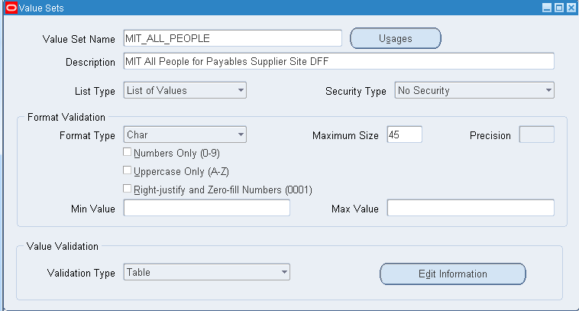

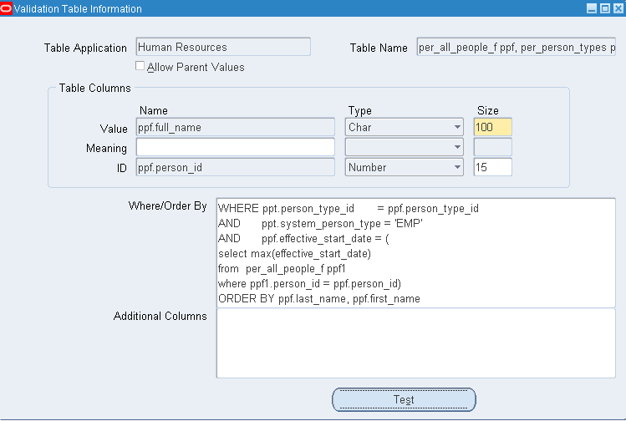

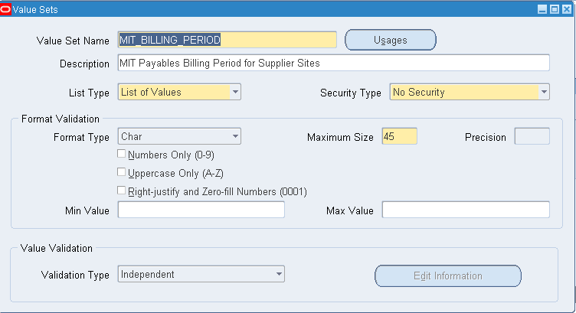

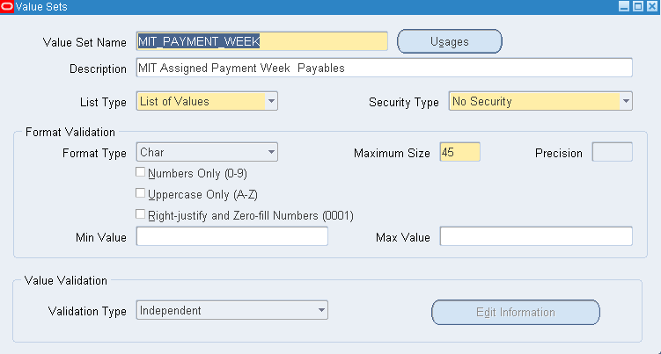

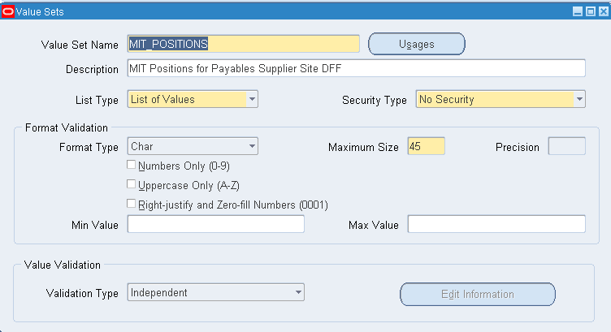

Define Value Set Values
Responsibility: System Administration
Menu Path: Flexfield -> Validation -> Values
Form: Value Sets Values
Purpose: Define Value Sets used in the Supplier Site DFF

Load the new value set values using Data Loader files MIT_POSITIONS.dld, MIT_PAYMENT_WEEK.dld and MIT_BILLING_PERIOD.dld.

Define Descriptive Flexfield Segments
Responsibility: System Administration
Menu Path: Flexfield -> Descriptive-> Segments
Form: Descriptive Flexfield Segments
Purpose: Define Supplier Site DFF

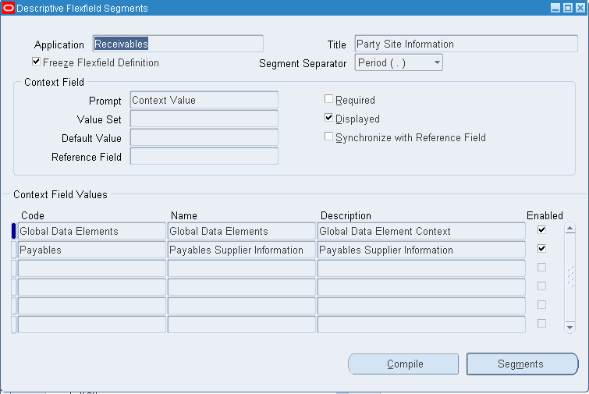

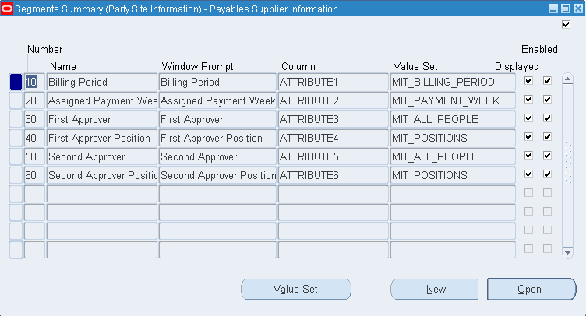

Assigning Default Expense Accounts to Suppliers
To include account codes and descriptions in the report, you need to use the existing Distribution Set functionality to assign default expense accounts to new and existing suppliers.

- Define the Distribution Set for the relevant Operating Unit in the MEL IT Payables Supplier Manager responsibility if one does not already exist.
  - Use menu path -> Setup: Invoice: Distribution Sets
  - You can define % splits across multiple accounts or use 100% allocation to a single account

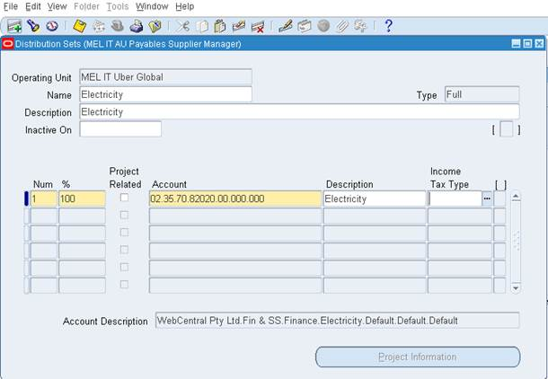

- Update the Distribution Set field in the Accounting Zone for the relevant site and operating unit in the Suppliers Form.

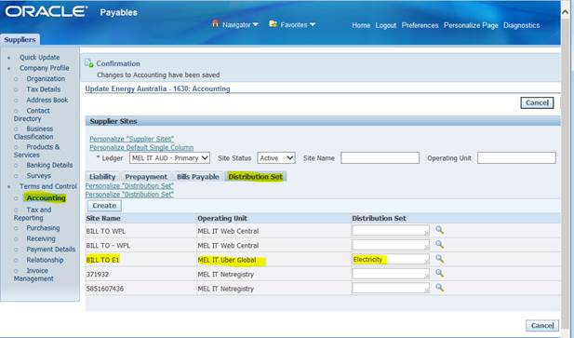

- The Distribution Set will then automatically populate the Distribution Set field in the Invoice form
- Account codes will default from the Distribution Set in the Invoice Distribution zone when entering new invoices.

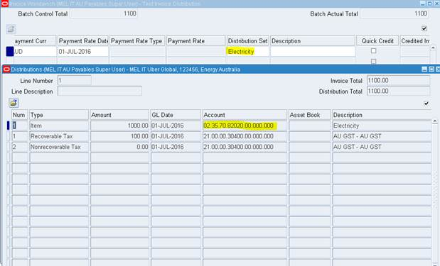

Entering Additional Supplier Site information
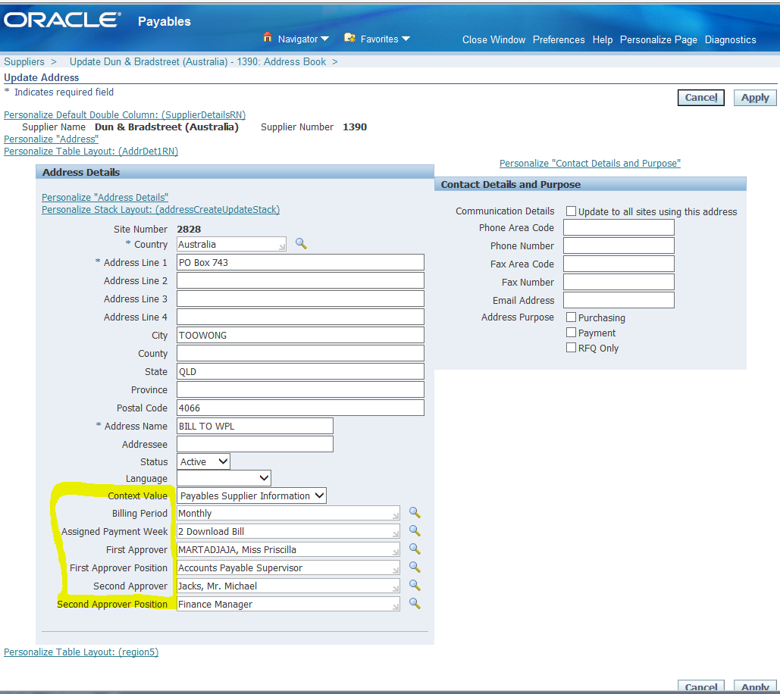

You can enter the additional information supplied by this report using the Supplier Site Descriptive Flexfield.

Select Payables Supplier Information in the Contect value and the new data fields will appear.
Select values from the LOVs to populate the new fields and save your changes.

Report Execution

- Login to your Payables Responsibility and execute the Concurrent Requests program.
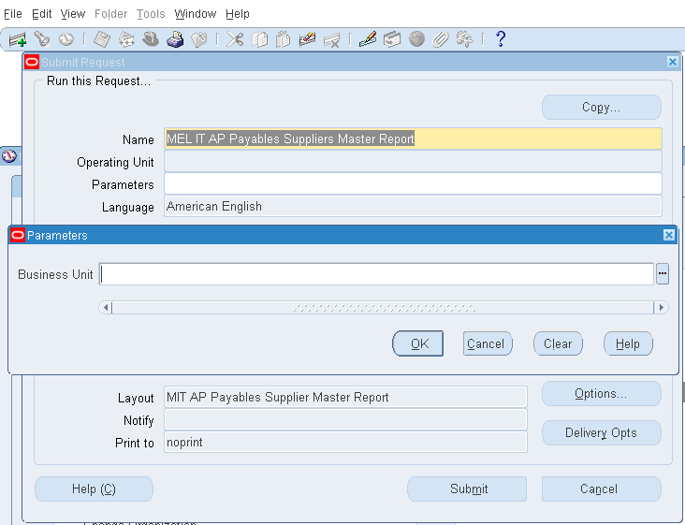

- Enter or select MEL IT AP Payables Suppliers Master Report as the Name.
- Enter or select the required Parameters to limit the report data:-
  - Business Unit
- Submit the Report.
- Execute the View -> Requests menu.
- Click the View Output button in OFC Requests form
- Click the Open or Save option in the Internet Explorer window. This will save the report in your standard Downloads folder.

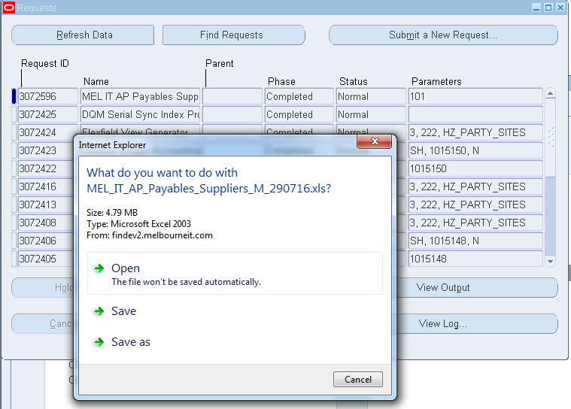

- Navigate to your Downloads folder and open the report file.

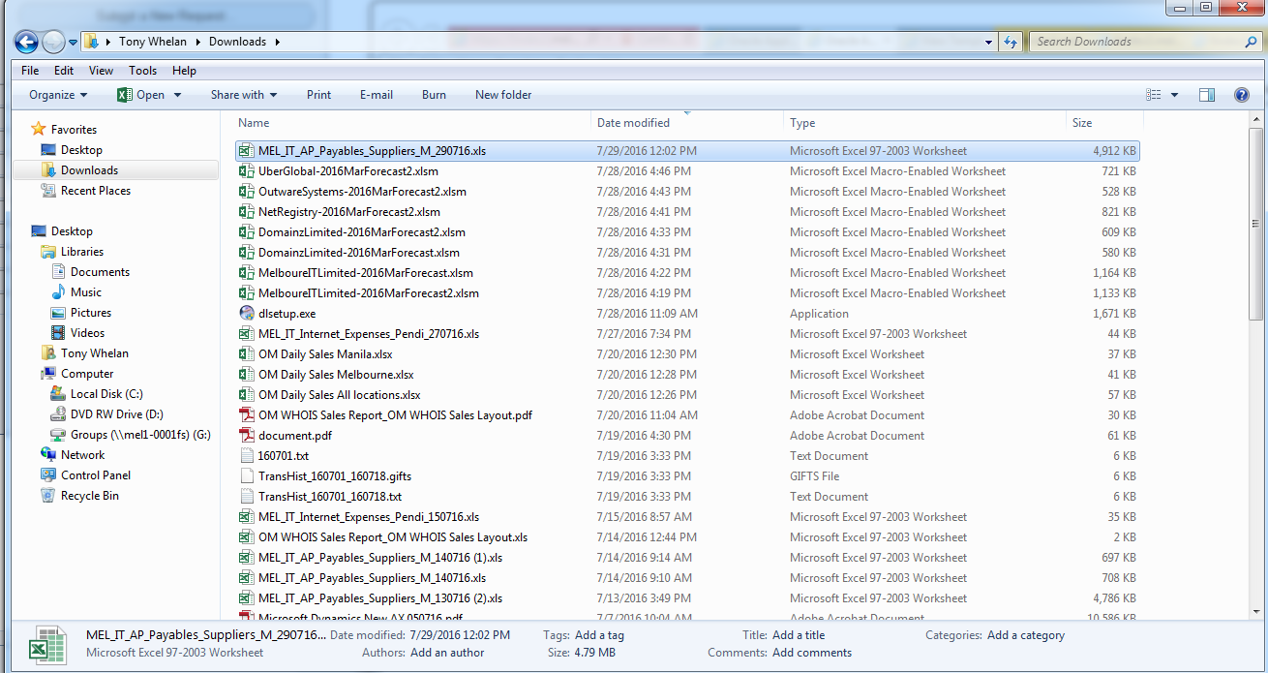

- Click ‘Yes’ to ignore the file format extension warning due to different versions of Excel between OFC and MIT.
- The report output will be displayed in Excel format.

